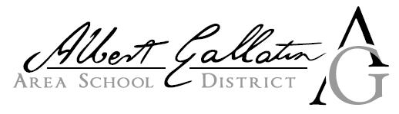
2625 Morgantown Road Uniontown, PA 15401 PHONE :(724)564-7190
___________________________________________________

Updated Degree/Certification

*Please print all information and return this form, as well as a copy of the new degree/certification via email to Payroll at:
jshwallon@agasd.org

Please complete this form if you have recently completed courses to update your degree and/or certifications. Please note that if you are informing the District of a Master’s Degree, you must notify us one (1) month prior to the new school year to receive the Master’s Degree pay increase. If you complete the degree mid-year, you will get the pay increase at the beginning of the following school year, no exceptions.

Name__________________________________________________________________

Certification/Degree Received __________________________________________

Date Received _________________________________________________________

___________________________________ __________________________
^{Signature} ^{Date}

*Office Use Only*

Received by: ______________________________ Date: ________________________

